PowerApps L1 Hands-On Exercises

Note: To complete this exercise you need to create free PowerApps subscription. Use the below link to create the subscription

<https://signup.microsoft.com/Start?sku=powerapps_viral&ru=https%3a%2f%2fweb.powerapps.com%2flogin%2fportal>

OR

<https://powerapps.microsoft.com/en-us/>

Scenario

House Flooring, the Specialist Manager in-charge of allocating the Floor specialists keeps a list of the Specialist requests in an Excel spreadsheet. Whenever a Salesperson requires the help of a Specialist, he/she will do either the following:

1. A Salesperson calls/emails the Manager
2. The Manager allocates an available Specialist
3. The Manager informs both the Salesperson and the Specialist
4. The Manager then updates the spreadsheet

You, the Business Analyst, have been asked to help streamline and automate this process.

Creating an App from Excel Data

After discussing the process with the Specialist Manager, you decide to build a demo app based on his existing Excel data to showcase how PowerApps can help to solve his problem.

The Excel spreadsheet (named Requests.xlsx) with following columns

|  |  |  |  |  |  |
| --- | --- | --- | --- | --- | --- |
| Title | Description | Date | Status | SpecialistName | Comment |

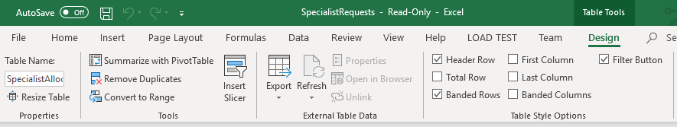

Upload the file to OneDrive in your trial account. Follow the below steps:

1. Go to https://web.powerapps.com.
2. Click on the menu in the top left-hand corner.
3. Click OneDrive under My Apps.
4. After a few seconds, click on the link for Your OneDrive is ready
5. Click Upload and choose Requests.xlsx.
6. Click Done

CONNECTING TO THE EXCEL FILE

1. Go to https://web.powerapps.com.
2. Ensure that you are in the Contoso Test environment, hover over Start from data and then click Make this app.
3. Select Phone layout under OneDrive for Business.
4. Click Create to build a connection to your OneDrive.
5. SelectRequests.xlsx under Choose an Excel file on the right section of the screen.
6. Select SpecialistAllocation under Choose a table on the right section of the screen.
7. Click Connect.
8. Click in the bottom of the app screen to select the entire BrowseGallery1.
9. For Layout in the Gallery section on the right side of the screen, Select Title, Subtitle, and body.
10. Ensure that the following fields are set accordingly:

* Body1: Description
* Subtitle1: Date
* Title1: Title

1. Now we are going to add a descriptor to the title field. In the Screens section, click on Title1 under BrowseGallery1.
2. In the Function bar, place your cursor in front of ThisItem.Title and add the following text: "Customer: " &
3. At the current moment, the App title is SpecialistAllocation. Let’s edit this to be easier to read. Click SpecialistAllocation on the app.
4. In the function bar, edit the text to be: “Specialist Requests”. Be sure to include the quotation marks.
5. Click File and click App settings.
6. Under App name enter Specialist (Excel).
7. Click Save as, leave it set to The cloud and click Save in the bottom right.
8. Click the back arrow in the top Left of the screen.
9. Run the app on the web browser by selecting the play icon in the top right corner of the screen.
10. Installing the Mobile App
11. In your mobile phone, or a Windows based PC, download the PowerApps player app from the respective app store.
12. Sign in using your user name and password.
13. Run the Specialist (Excel) app on your mobile phone.